Lab Assignment -1

**Name:** J Viswaksena **Roll.no:** AM.EN.U4AIE21035

Design DFA for the following languages.

1. DFA for strings over the alphabet {a, b}
   1. [starting with a and ending with a](https://t4tutorials.com/finite-state-automata-fsa-for-starting-with-a-and-ending-with-a-in-theory-of-automata/?amp).

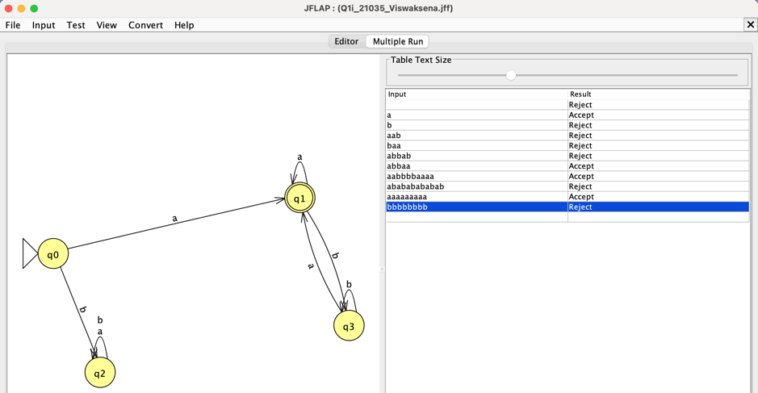

* 1. [starting with a](https://t4tutorials.com/finite-automata-fa-for-the-language-of-starting-with-a-in-theory-of-automata/?amp).

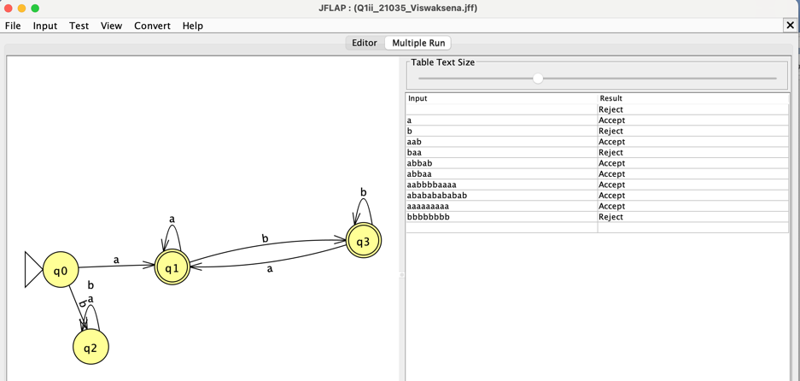

* 1. containing [aa as a substring](https://t4tutorials.com/finite-automta-for-the-language-of-all-those-string-containing-aa-as-a-substring-in-theory-of-automata/?amp).

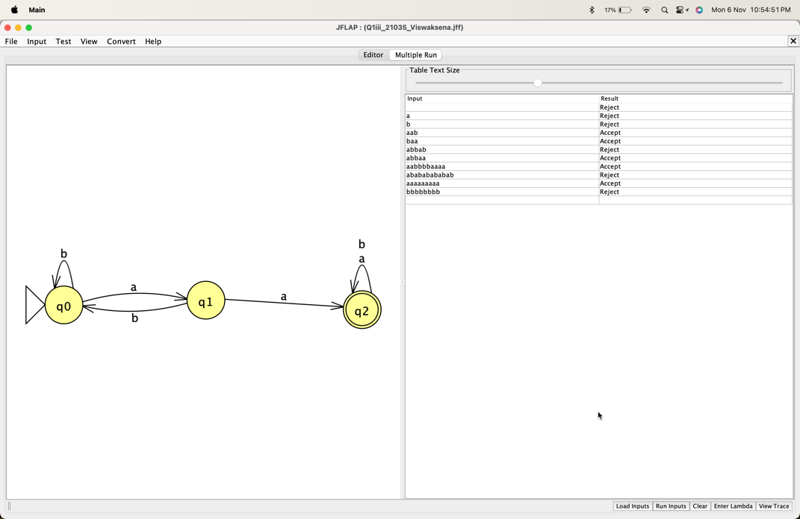

* 1. [starting and ending with the same letters](https://t4tutorials.com/finite-automata-fa-for-the-language-of-all-those-strings-begining-and-ending-with-same-letters/?amp).

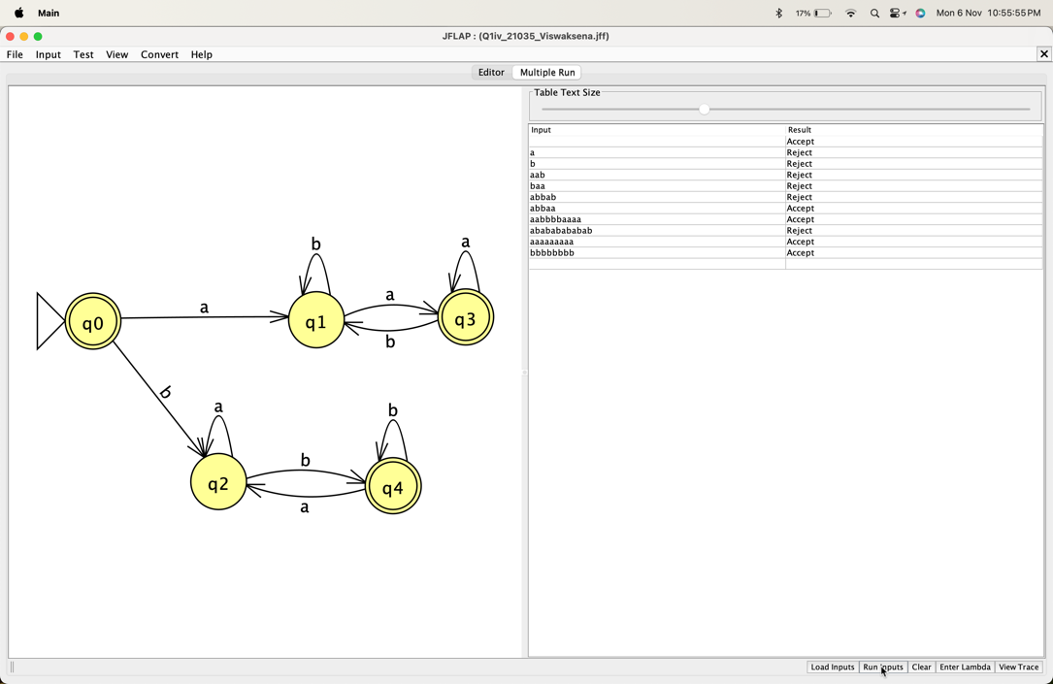

* 1. [starting and ending with different letters](https://t4tutorials.com/finite-machinefinite-state-automata-in-theory-of-computation/?amp).

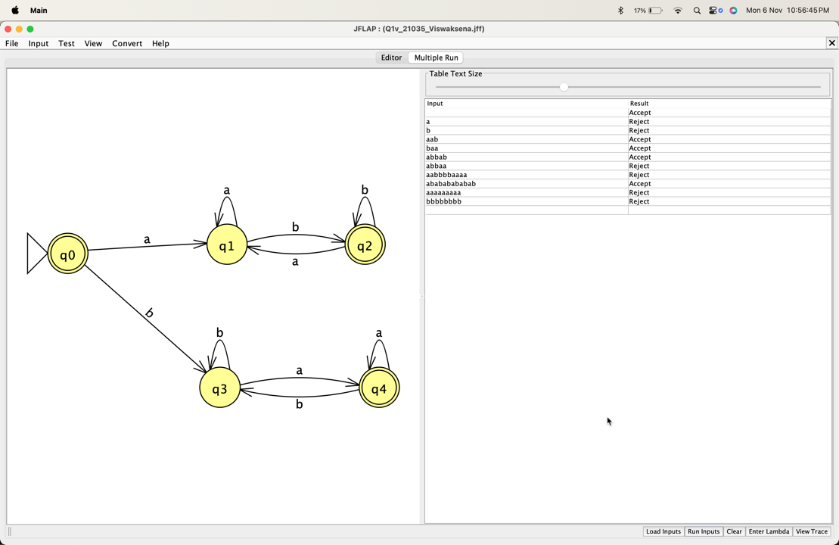

1. DFA for strings over the alphabet {0, 1}
   1. L={w/w starts with a 0 where w ∈ {0, 1}*}

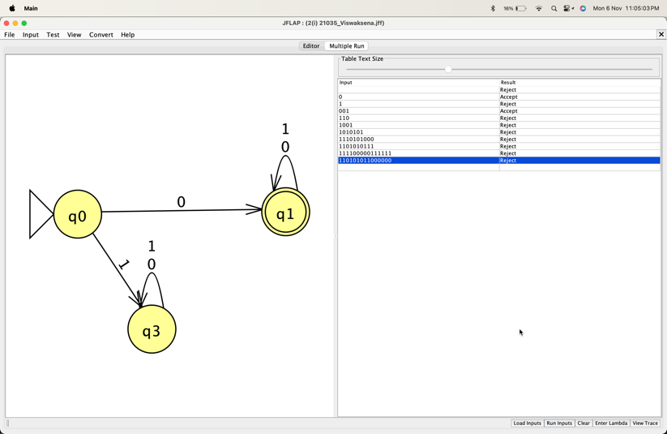

* 1. L={w/w ends with a 1 where w ∈ {0, 1}*}

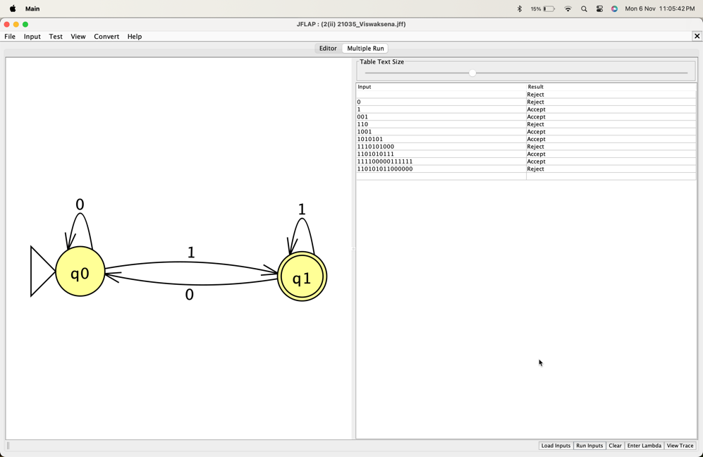

* 1. L={w/w has length exactly 2 where w ∈ {0, 1}*}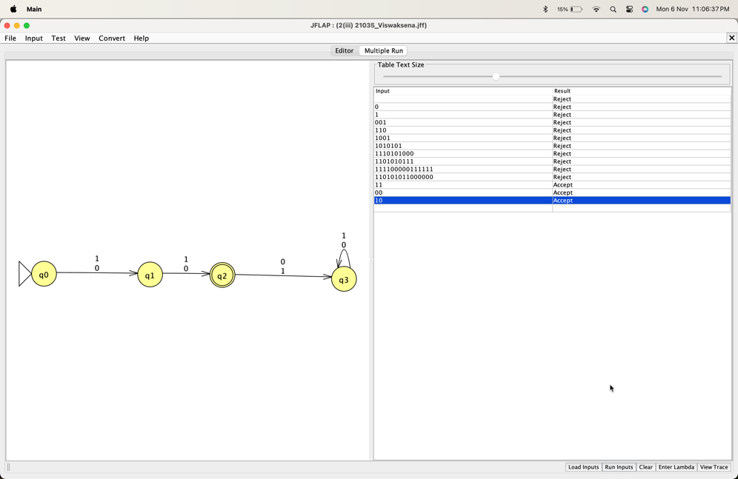
  2. L={w/w has length at most 2 where w ∈ {0, 1}*}

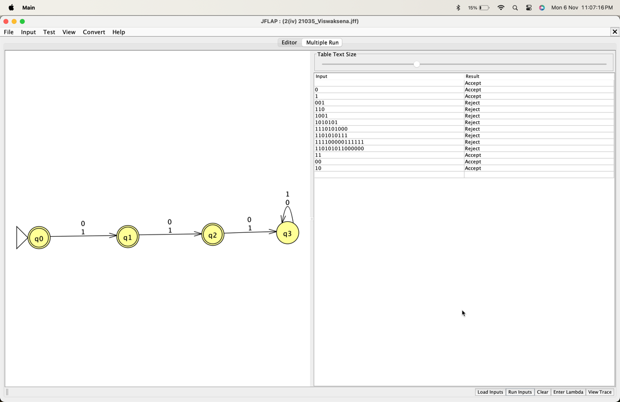

* 1. L={w/w contains the substring 11 where w ∈ {0, 1}*}

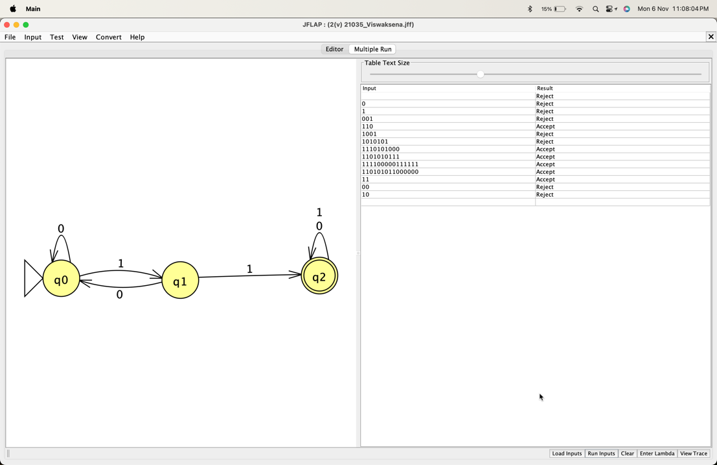

1. L={aw1aaw2a : w1, w2 ∈ {a, b}*}

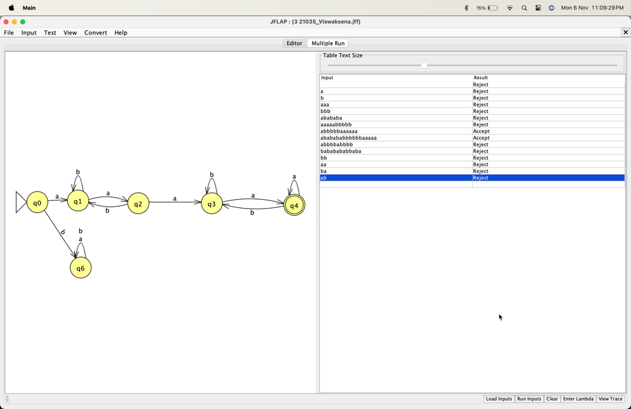

1. L={ban : n ≥ 1, n ≠ 4}

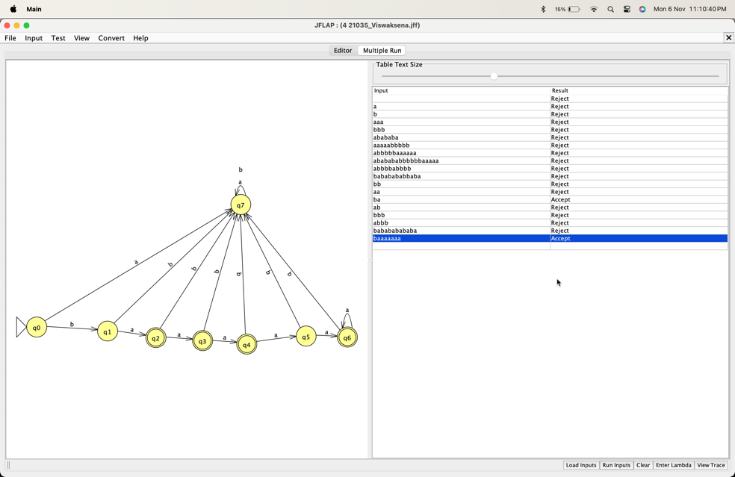

1. L={w | na(w) mod 3 = 0 and nb(w) mod 2 = 0}

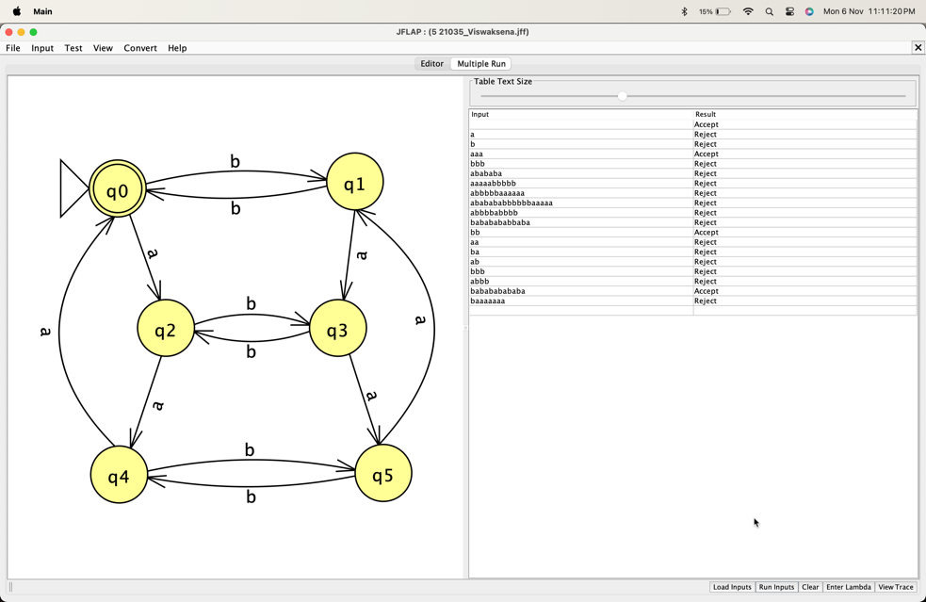

1. L={w : there are exactly two runs of *a*’s of length 3} on {a, b}}

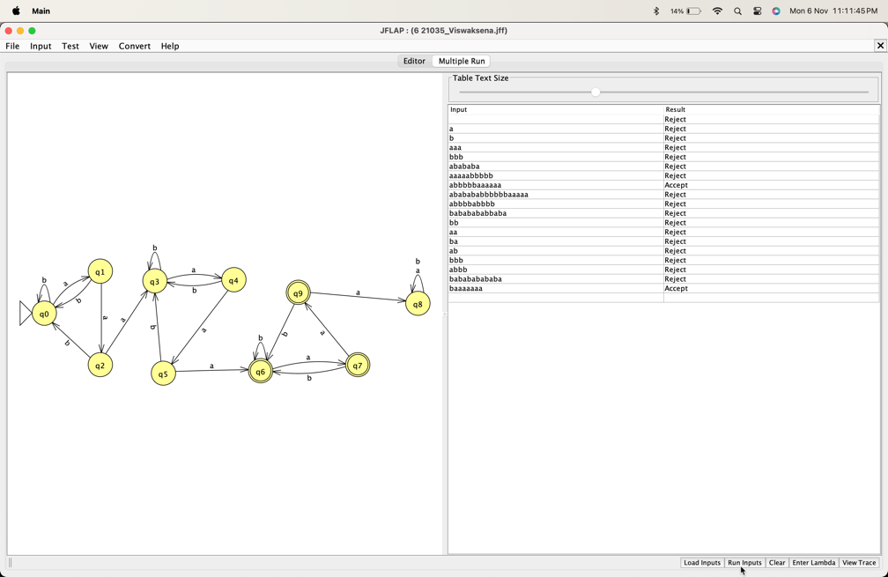

1. All strings with at least one b and exactly two a’s on {a, b}

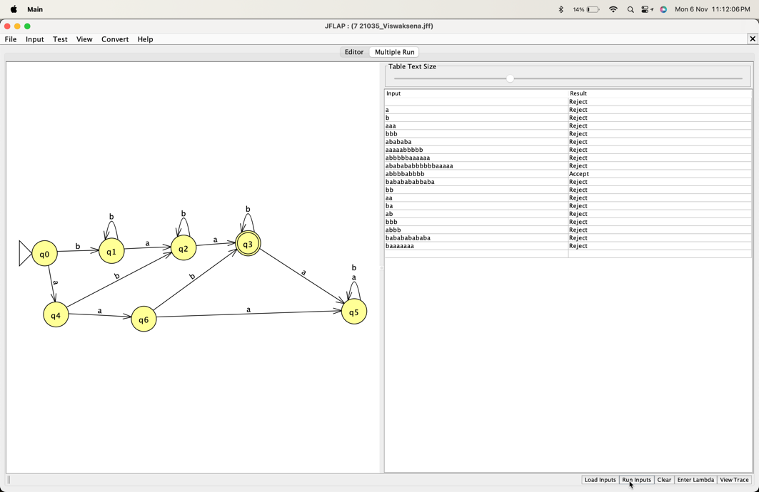

1. All strings that contain substring 000, but not 0000 on {0,1}.

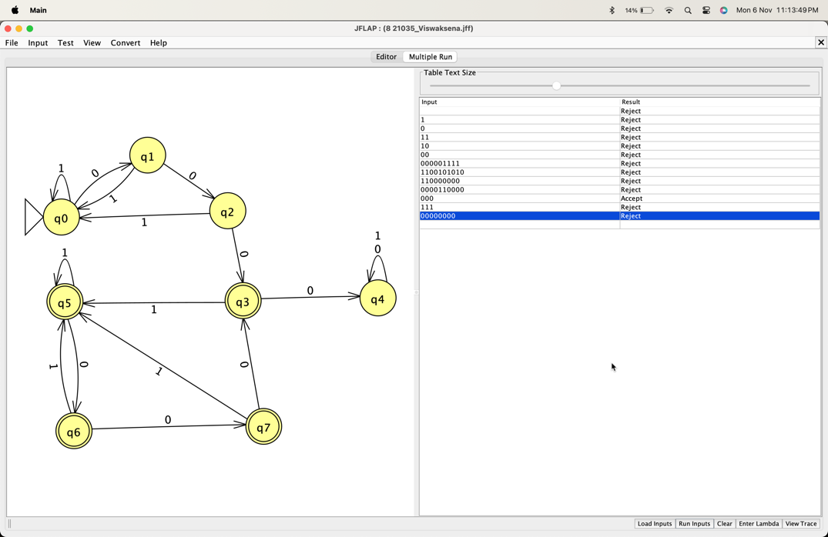

1. Construct deterministic finite automata (DFA) for the language L = { w : w

has odd number of 0’s and w has odd number of 1’s},over the alphabet Σ =

{0, 1}.

